Standardization vs. Normalization

1. Standardization
- What it does:
Transforms data to have a mean of 0 and a standard deviation of 1.
Formula:

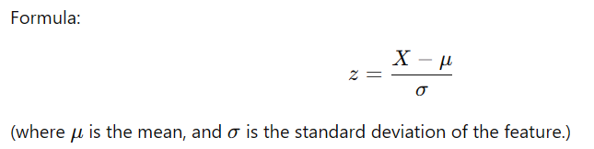
- When to use it:
  - Features have different units or scales (e.g., age in years, income in dollars).
  - Algorithms that assume normality or are sensitive to scale, such as:
    - Principal Component Analysis (PCA)
    - Linear Discriminant Analysis (LDA)
    - Logistic Regression
    - SVMs, KNN, or any distance-based model.
- Why it's enough in most cases:
Standardization is sufficient when your goal is to compare features with different scales or when algorithms rely on distance or variance.

2. Normalization
- What it does:
Scales data to a fixed range, typically [0, 1].
Formula:

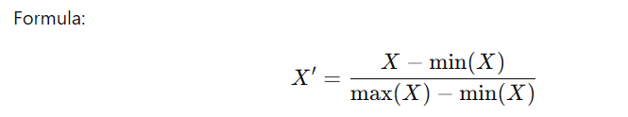
- When to use it:
- Features have widely varying magnitudes.
- Algorithms sensitive to absolute magnitudes or expected in a bounded range, such as:
  - Neural Networks (to optimize gradient descent performance).
  - Clustering algorithms like K-Means.
- Why it might not always be necessary:
Normalization removes information about the variance, which PCA or LDA rely on. In such cases, normalization after standardization might harm the analysis.

Should You Use Both?
Not usually. Using both standardization and normalization together can often lead to redundant preprocessing or distortions. Here’s how to decide:
- If you’re using PCA or LDA:
  - Standardize only. These techniques rely on variance and don't require data in a specific range.
- If you’re using Neural Networks:
  - Consider normalization, as gradient descent works better when features are in the same range.
- For clustering (like K-Means):
  - Either standardize or normalize, depending on the feature distribution.
- For distance-based algorithms (KNN, SVM):
  - Standardize only, as these algorithms care about relative distances, and normalization isn't strictly required.

Summary
- For PCA/LDA and most ML tasks, standardization is enough.
- For algorithms like Neural Networks or clustering, normalization might be added if the algorithm benefits from bounded data.
- Avoid over-preprocessing—choose based on the specific algorithm and data characteristics.

